Classical Golden Triangle

Day 01 Arrive Delhi
On arrival at Delhi International Airport, you’ll meet our representative who will assist you and further accompany you to your hotel.
Overnight in Delhi

Day 02 Delhi
Post breakfast, proceed for our unique yet fascinating experience of Old Delhi. Drive past Red Fort (Closed on Mondays) – Shah Jehan’s elegant citadel in red sandstone, the Jama Masjid – India’s largest mosque. Enjoy Cycle Rickshaw Ride in the narrow-crowded lanes of Old Delhi. The thrill of being driven through the narrow, Winding lanes is a memorable experience. Explore Chandni Chowk and visit Digambar Jain Temple.
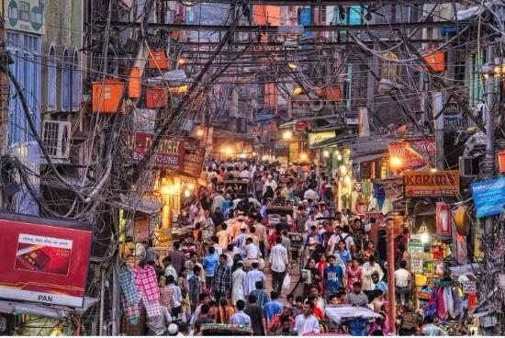
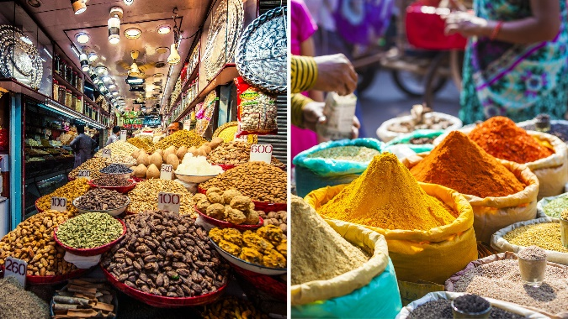

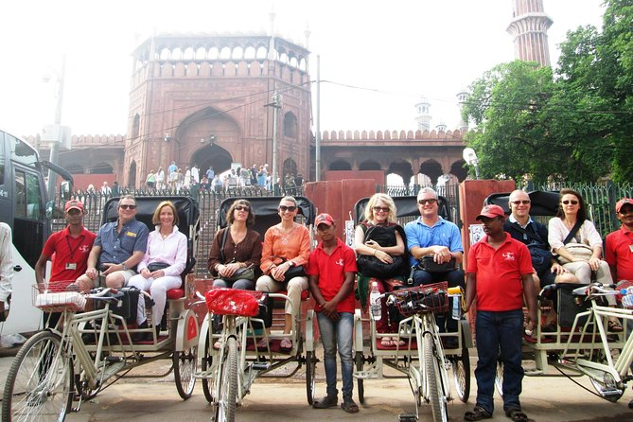

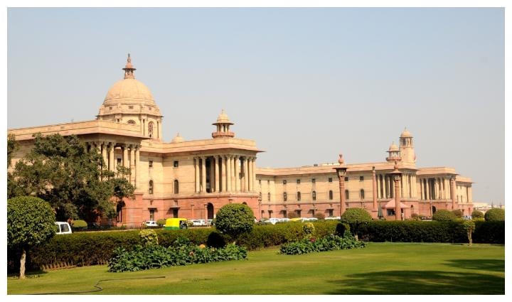
Later, proceed to the new capital designed by Sir Edward Lutyens. Drive past the Presidential Palace, the Rashtrapati Bhawan and the secretariat buildings - the center of all government activity and down the main avenue, the impressive Rajpath to the World War I memorial arch, the India Gate, the High Court Building, and the Old Fort. Continue to visit Humayun’s Tomb, this magnificent garden tomb is the first substantial example of Mughal architecture in India. It was built in 1565 A.D. nine years after the death of Humayun. Visit Qutab Minar, 72 meters high and the ruins of Quwat-ul-Eslam (Light of Islam) Mosque. See Delhi’s most curious antique, the un-corroded Iron Pillar, which dates to the 4th century AD.
Overnight in Delhi
Day 03 Delhi – Agra (04 hrs drive)
After breakfast, depart for Agra by surface and transfer to the hotel.
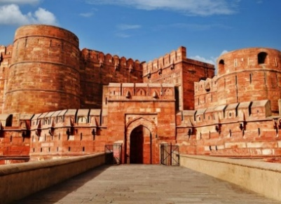
Afterwards, visit the Agra Fort –built 16th century AD, and added upon by 3 generations of Mughal emperors, it is a mix synthesis of military fortifications with delicate interior details. The Mughal Emperor Shah Jahan was imprisoned by his son here.

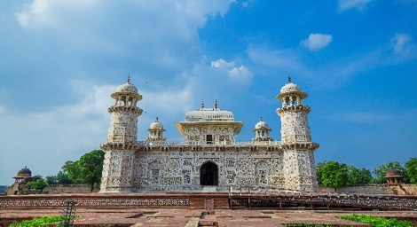
Later, visit Itmad-ud-Daulla Tomb, often referred to as the "Baby Taj Mahal", the tomb of Itimad-ud-daulah is a Mughal mausoleum and often regarded as a copy of the Taj Mahal. This is the first tomb in India made entirely of marble. The tomb was commissioned by Nur Jahan, the wife of Jahangir, for her father Mir Gheyas Beg (later known as Itimad-ud-daulah), who was a minister in the court of Shah Jahan.
Overnight in Agra

Day 04 Agra – Fatehpur Sikri – Jaipur (06 hrs drive)
Early morning, visit the incomparable Taj Mahal at Sunrise (Closed on Fridays). Experience the sublimity of the Taj Mahal – a varying kaleidoscope of solitude, colour and mood. A tribute from a great emperor to the memory of his beloved wife, it was 22 years in the making and is a cerebral experience that defies description. Widely regarded as the earthly replica of paradise, Taj Mahal is likened to “a vision, a dream, a poem and a wonder”.
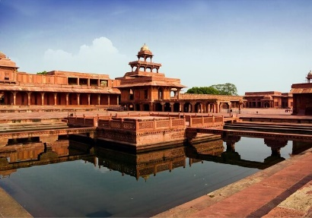
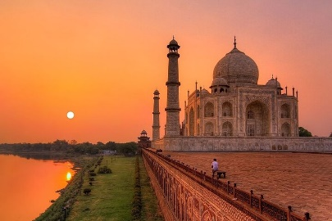
Post breakfast, depart for Jaipur enroute visiting Fatehpur Sikri – an exquisite city built by Akbar the Great in 1569, in red sandstone, with its forts, palaces and mosques, and abandoned after its creation due to political reasons.

Continue to Jaipur and check-in at the hotel. Rest of the day is at leisure.
Overnight in Jaipur

Day 05 Jaipur
After breakfast, proceed on a guided excursion to Amber Fort – originally the ancient capital of the Kachawahas clan from 1037 the ancient town of Amber, 12km from Jaipur, is dotted with ancient temples, Havelis, and step wells. High above the town and surrounded with defensive fortification walls sits the impressive Amber Palace. Built by Raja Man Singh in the early 17th century it houses mighty gates, temples, huge ornate halls, palaces, pavilions, and gardens. Amber Palace is a perfect blend of Hindu and Muslim architecture and once at the top the Palace affords excellent views of the surrounding countryside and town below. The 10-minute walk through a series of five defensive gates will bring you to the Suraj Pol (Sun Gate), the main entry to the Palace.
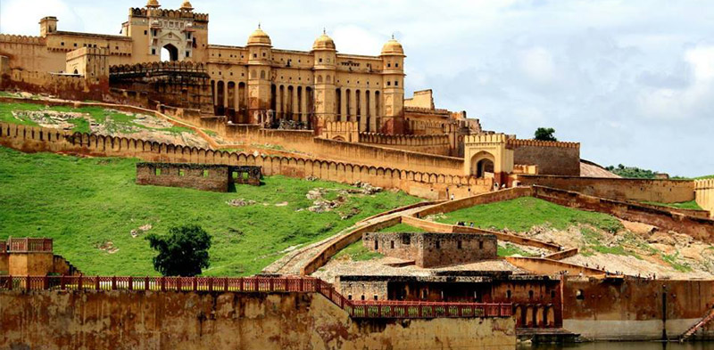

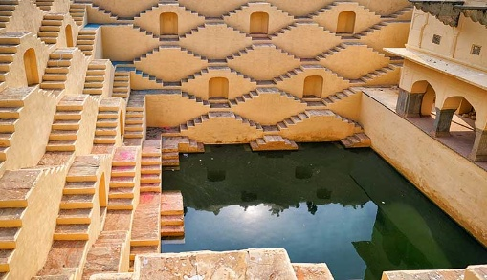
Later, visit Panna Meena Step Well – The eight storey Step well was built in 16th century as a sort of community gathering area. A place where people could come for water, a swim, a chat with a neighbor or relax. The criss-cross of stairs, the octagonal gazebos, and the recessed doorways--this baoli is fun to walk around and photograph. According to the residents of the place, it is impossible for a person to use the same stairs to get down and go upstairs. It is a big mystery about the place and all the tourists visiting here try to do this.

In the afternoon, return to the town to do a tour of the city. Visit the City Palace – the former royal residence and the Jantar Mantar – a stone astrological and astronomical Observatory built by Maharaja Jai Singh in the 18th century. Photo stop – at the Hawa Mahal, known popularly as the Palace of Winds.

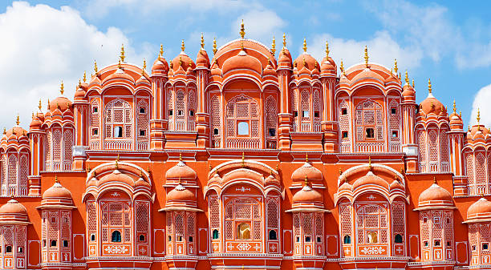
Take the opportunity also to wander through the traditional markets.
Overnight in Jaipur.

Day 06 Jaipur – Delhi (05 hrs drive)
In the afternoon, transfer from Jaipur to Delhi International Airport to connect international flight to the next destination.

End of Tour

Classical Golden Triangle
(Cost / Terms & Conditions)

Based on the following hotels:

City | Standard Hotels | Superior Hotels | Deluxe Hotels | Luxury Hotels | Nights
Delhi | Africa Avenue  (Standard Room) | Colonel’s Retreat  (Standard Room) | Eros Nehru Place  (Superior Room) | The Imperial  (Imperial Room) | 02
Agra | Coral Tree Homestay  (Standard Room) | Ekaa Villa  (Queen Room) | Taj View  (Deluxe Room) | The Oberoi Amarvilas  (Premier Room) | 01
Jaipur | Khandela Haveli  (Deluxe Room) | Shahpura House  (Suite) | Samode Haveli  (Deluxe Room) | Rambagh Palace  (Palace Room) | 02

*B-Breakfast, L-Lunch, D-Dinner

Prices: (Valid for 01 Oct 2025 – 31 Mar 2026)

Particulars | Prices – Per Person (EUR)
 | Standard Hotels |  | Superior Hotels |  | Deluxe Hotels |  | Luxury Hotels
 | 02-03 Pax | 04-06 Pax | 02-03 Pax | 04-06 Pax | 02-03 Pax | 04-06 Pax | 02-03 Pax | 04-06 Pax
Per Person on Twin  Sharing Basis | 445.00 | 390.00 | 570.00 | 515.00 | 945.00 | 890.00 | 2545.00 | 2495.00
Single Room Supplement | 185.00 | 185.00 | 285.00 | 285.00 | 685.00 | 685.00 | 2290.00 | 2290.00
Monument Entrances | 110.00 | 110.00 | 110.00 | 110.00 | 110.00 | 110.00 | 110.00 | 110.00
Local English / French Speaking Guide | 80.00 | 40.00 | 80.00 | 40.00 | 80.00 | 40.00 | 80.00 | 40.00
Accompanying French Speaking Guide | 110.00 | 55.00 | 110.00 | 55.00 | 110.00 | 55.00 | 110.00 | 55.00

* Above prices are not valid from 20 Dec 2025 till 10 Jan 2026 (both days included)

The above price includes:
- Accommodation in single / twin rooms at the above-mentioned hotels or similar
- Meals: Bed & Breakfast basis
- Transportation by AC Toyota Crysta Car (02-03 Pax) or AC Tempo Traveler (04-06 Pax) as per the program
- Cycle Rickshaw Ride in Old Delhi
- GST (Goods & Services Tax) as applicable

The above price does not include:
- Any domestic/ international airfare
- Monument entrance fees & services of the guide/s
- Any expenses of personal nature like tips, laundry, beverages, spa, telephone calls etc.
- Any expenses caused by factors beyond our control like flight cancellation, roadblocks, vehicle malfunction, natural calamities etc.
- Any medical or evacuation insurance
- Travel insurance
- Any other thing not mentioned in the Program/ Inclusions

